|  |  |
| --- | --- |
| **EX.NO:20** | **E-BOOK MANAGEMENT SYSTEM** |

USECASE DIAGRAM:

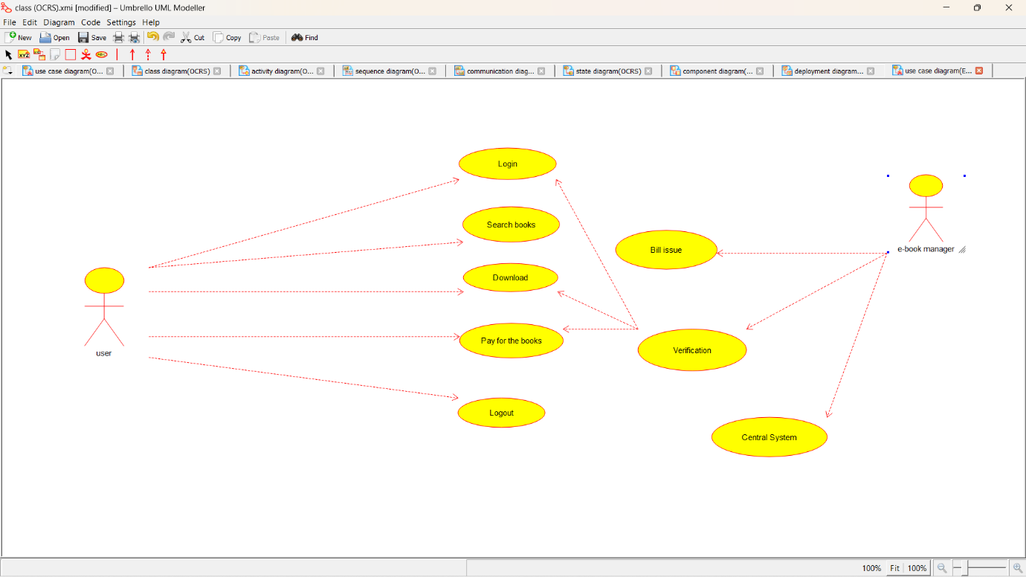

CLASS DIAGRAM:

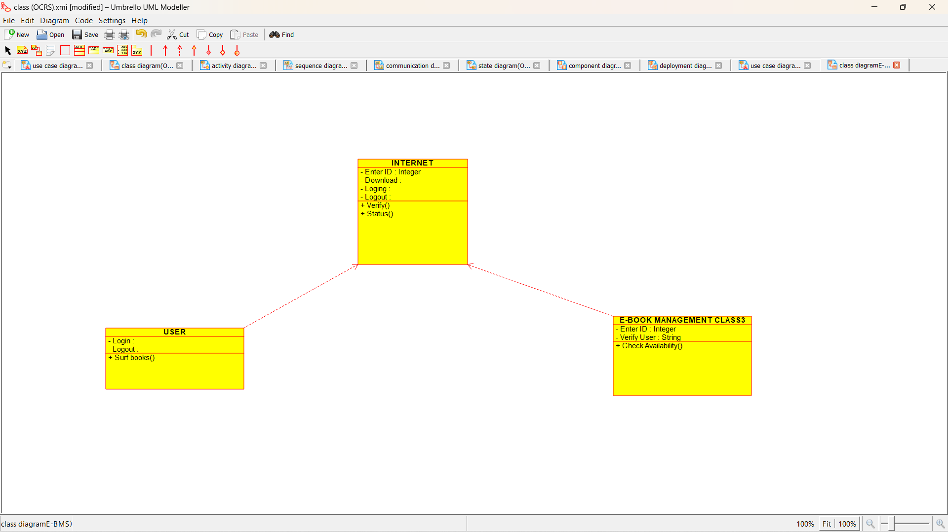

ACTIVITY DIAGRAM:

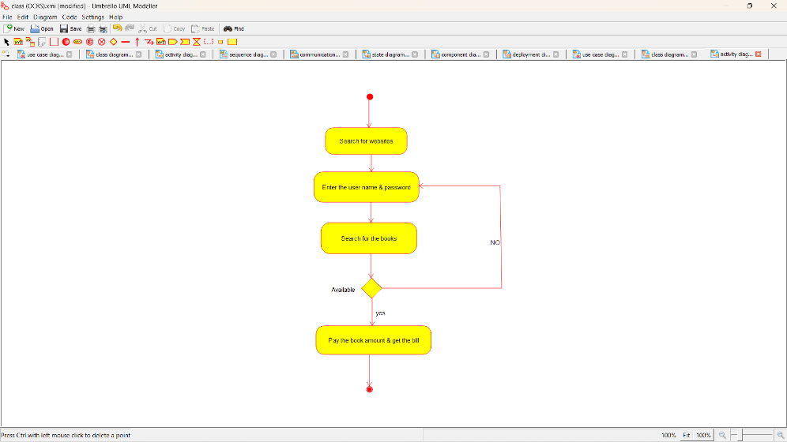

SEQUENCE DIAGRAM:

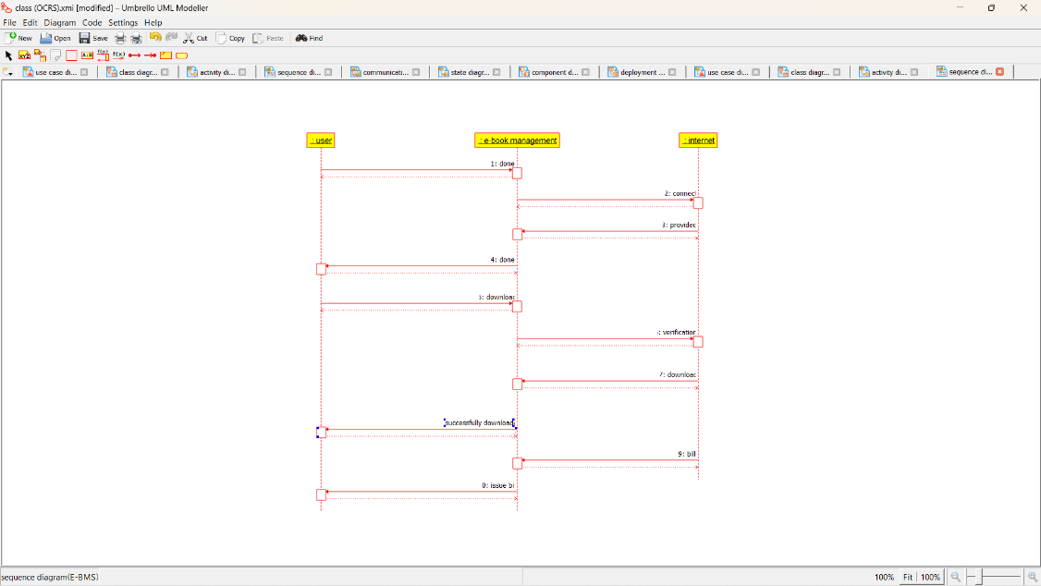

COLLABORATION DIAGRAM: 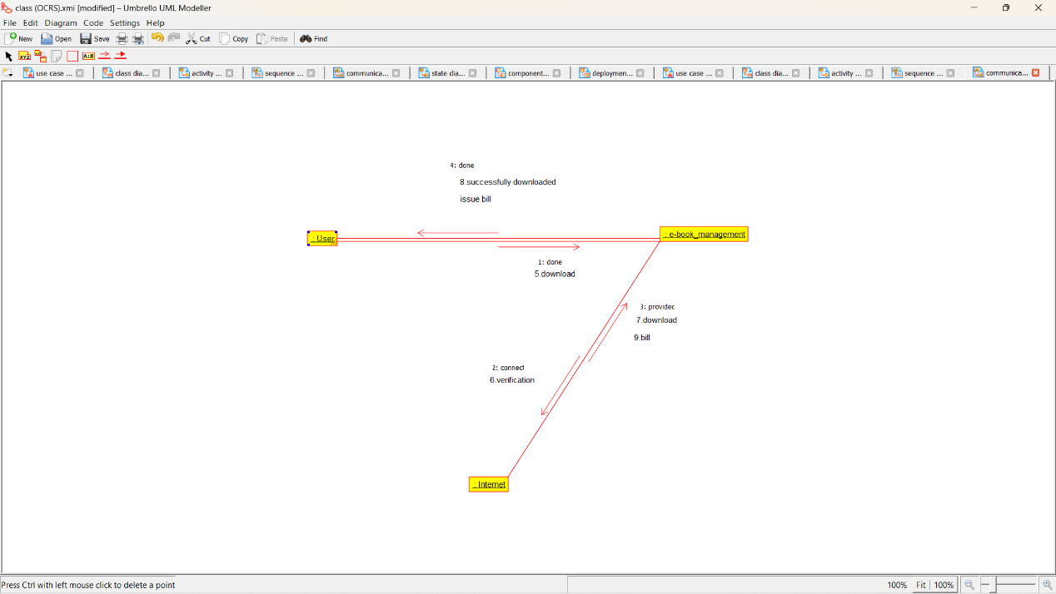

STATE DIAGRAM: 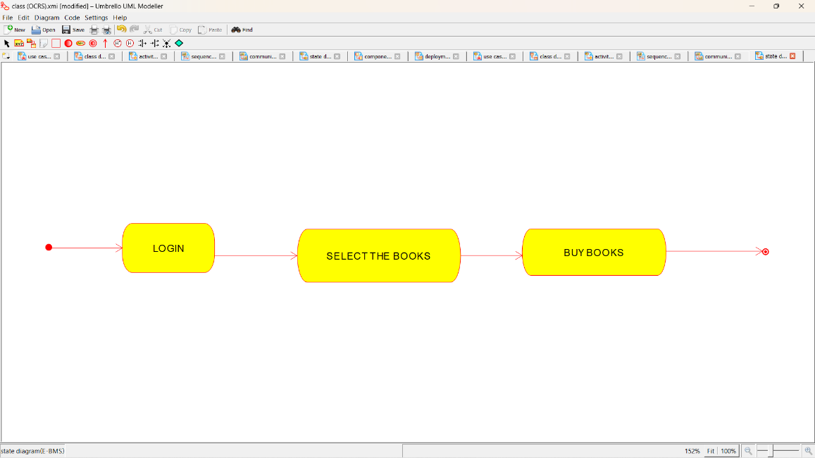

COMPONENT DIAGRAM: 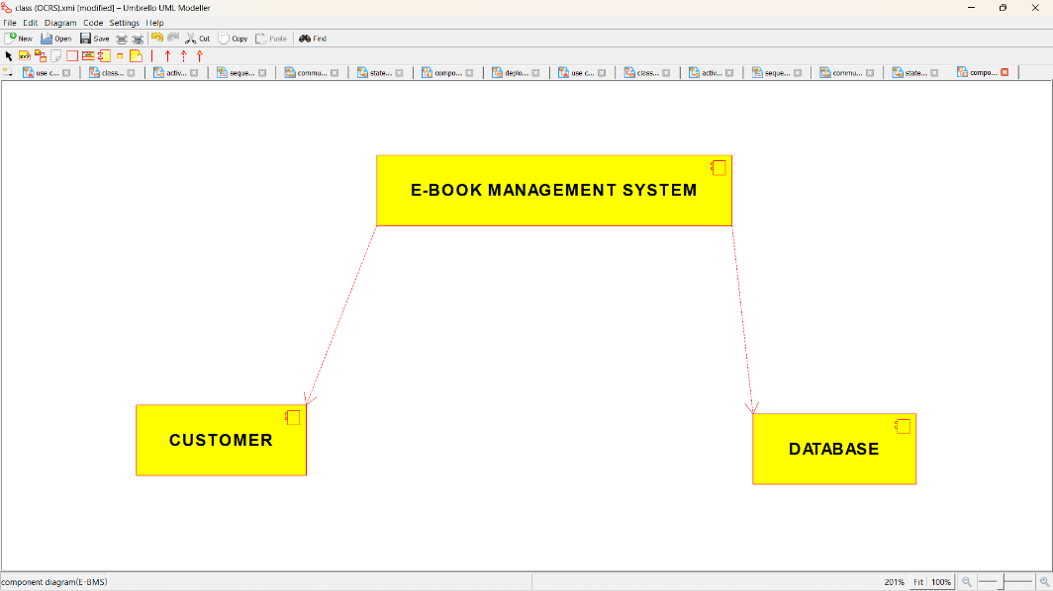

DEPLOYMENT DIAGRAM:

